Use Cases Description
UC8- Recycle Bin Management

For

Meeting Room
Booking System
(MRBS)

Prepared by K15T1-Team11
Van Lang University
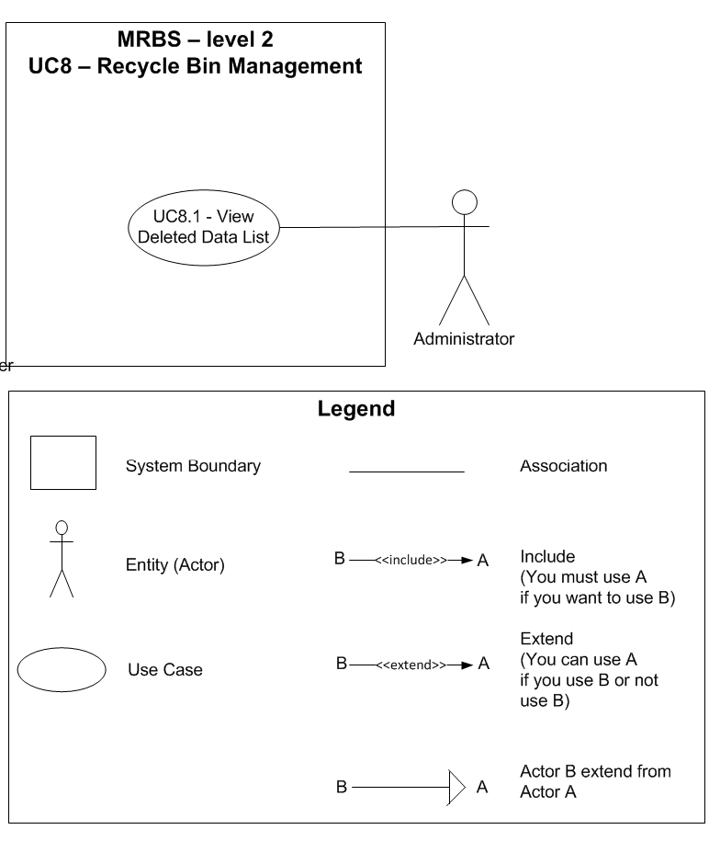

Table of Contents
UC1.1 – View Account List 4

UC8.1 – View Deleted Data List
ID | UC8.1
Name | View Deleted Data List
Author | Tam Do | Modify by
Date | 06/29/12 | Update
Actor | Administrator
Description | User can view a list of deleted data from other activities, such as: delete account, delete room, delete group borrower, delete borrower
Precondition | User signed in system by Administrator’s account
Post condition: | System shows all deleted data from other activities
Main flow: | 1. User press “Danh mục”  2. User choose “Quản lý thùng rác”  3. System show new dialog “Quản lý thùng rác”  4. System show a list of deleted data
Alternative flow:
Exception :
Includes:
Priority:
Business rules:
Mockup screen

